1. Selenium IDE -Selenium IDE (Integrated Development Environment) is a record and playback tool for creating automated tests in the browser. Allows testers to record their interactions with the web application and play them back as automated test cases. A simple interface for creating test cases without writing code.

Selenium WebDriver - Selenium WebDriver is a programming interface that allows testers to write code to automate web browser interactions. Supports automation across different browsers and platforms. Selenium WebDriver is suitable for automating complex web applications with dynamic content and interactions. It is often integrated with testing frameworks such as JUnit, TestNG, NUnit, etc., for structured test automation.

Selenium Grid - Selenium Grid is a tool for distributing test execution across multiple machines or browsers in parallel. Allows tests to be run concurrently across multiple browsers, operating systems, and machines. Supports running tests on different browsers and versions simultaneously.

1. Selenium script to open google and search for selenium browser driver:

**package** task;

**import** org.openqa.selenium.By;

**import** org.openqa.selenium.Keys;

**import** org.openqa.selenium.WebDriver;

**import** org.openqa.selenium.chrome.ChromeDriver;

**import** org.openqa.selenium.firefox.FirefoxDriver;

**import** io.github.bonigarcia.wdm.WebDriverManager;

**public** **class** Task15 {

**public** **static** **void** main(String[] args) {

// **TODO** Auto-generated method stub

WebDriverManager. *firefoxdriver* ().setup();

WebDriver driver=**new** FirefoxDriver();

driver.manage().window().maximize();

driver.get("https://www.google.com");

driver.findElement(By.*name*("q")).sendKeys("Selenium Brower Driver" +Keys.***ENTER***);

}

}

Output:

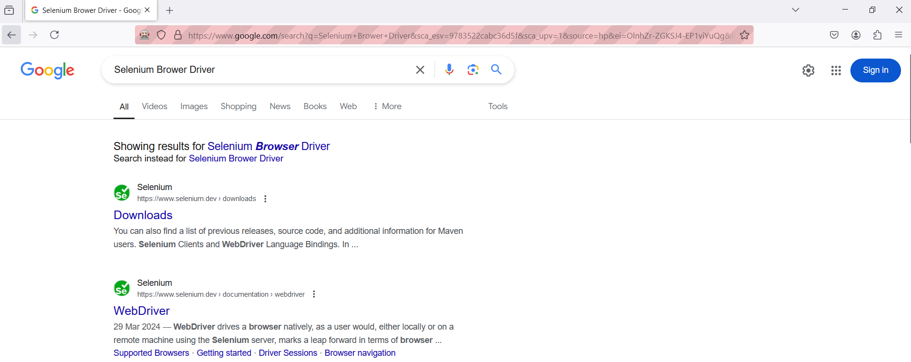

1. Selenium and how it is useful in Automation Testing:
   1. Selenium is an open-source, automated testing tool used to test web applications across various browsers. Selenium can only test web applications, unfortunately, so desktop and mobile apps can’t be tested. Selenium can test web applications against various browsers like Firefox, Chrome, Opera, and Safari .
   2. Tests can be coded in several programming languages like Java, Python, Perl, PHP, and Ruby.
   3. Selenium is platform-independent and can be integrated with tools like JUnit and TestNG for test management.
   4. Automated testing with Selenium can easily scale to cover a wide range of [test cases](https://www.browserstack.com/guide/how-to-create-selenium-test-cases), scenarios, and user interactions. This scalability ensures [maximum test coverage](https://www.browserstack.com/guide/how-to-ensure-test-coverage) of the application’s functionality.
   5. Selenium allows testers to create reusable test scripts that can be used across different test cases and projects. This reusability saves time and effort in test script creation and maintenance.
   6. Selenium supports parallel test execution, allowing multiple tests to run concurrently. This helps reduce the overall testing time.
2. Browser drivers used in selenium:

* ChromeDriver()
* EdgeDriver()
* FirefoxDriver()

1. Simple WebDriver script with explanation:

package demo;

import org.openqa.selenium.By;

import org.openqa.selenium.WebDriver;

import org.openqa.selenium.chrome.ChromeDriver;

import io.github.bonigarcia.wdm.WebDriverManager;

public class Facebooklogin {

public static void main(String[] args) {

// TODO Auto-generated method stub

// instantiate the browser driver

WebDriverManager.chromedriver().setup();

// create instance for chrome driver

WebDriver driver=new ChromeDriver();

// launch the facebookurl

driver.get("https://www.facebook.com/login/");

// maximize the browser window

driver.manage().window().maximize();

// get the title of the page

System.out.println(driver.getTitle());

// get the current url

System.out.println(driver.getCurrentUrl());

// enter the email id and password

driver.findElement(By.id("email")).sendKeys("ttk@gmail.com");

driver.findElement(By.id("pass")).sendKeys("abc123");

}

}